1.

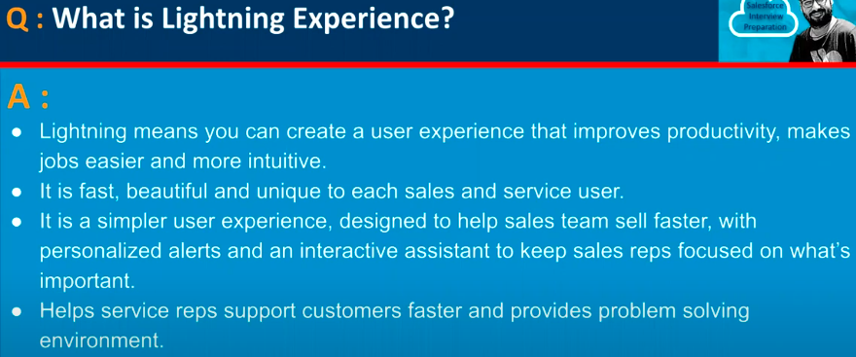

2.

3.

4.

5.

6.

7.

8.

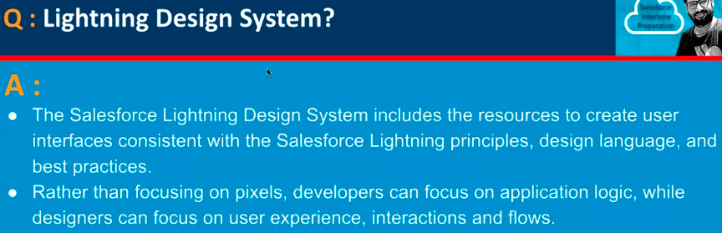

9.

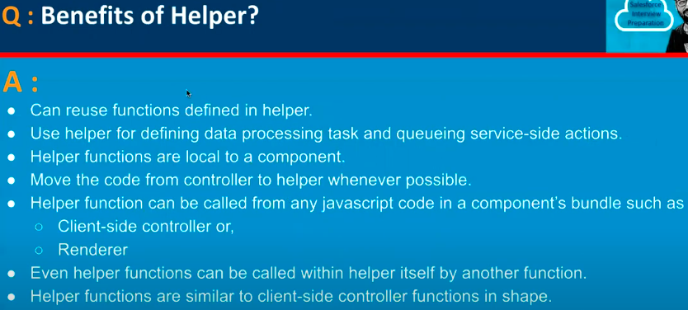

10.

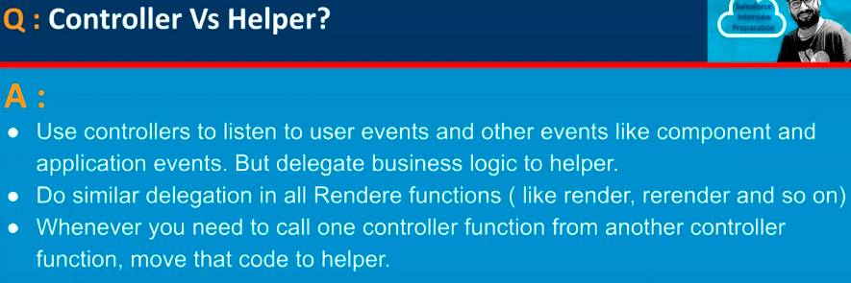

11.

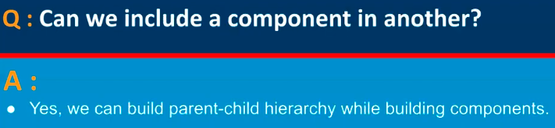

12.

13.

14.

15.

16.

17.

18.

19.

20.

21.

22.

23.

24.

25.

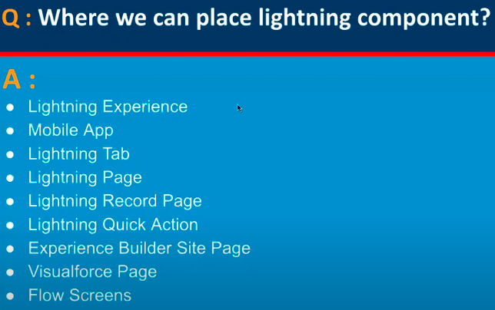

26.

27.

28.

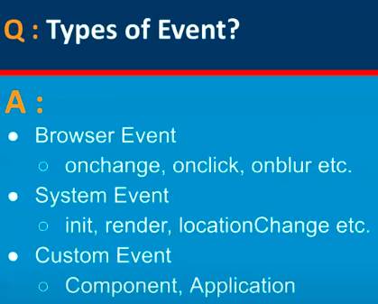

29.

30.

31.

32.

33.

34.

35.

36.

37.

38.

39.

